Data vs. Information

The database for PopPriceGuide.com gathers the final sale prices of all existing Funko Pop! figures from eBay. It then averages the final sale prices of each figure to give an estimated value of that particular figure. The data is the individual final sale prices, alone they mean nothing. When they are put together (given context) and averaged out, the estimated value is the information. This information allows the user to know whether or not they are being over/under charged for a figure. Users are also able to make a list of the figures they own and their estimated values. In this scenario, the estimated values are data. The site adds up the estimated values of the figures, and provides the user with information such as the estimated value of their entire figure collection. If they choose to sell their collection, they know how much money they should sell it for. When you contextualize data, it becomes useful information that you can base decisions on.

Data Models

The hierarchical model is a tree-based model, where everything relates back to one thing without loops. The network model is graph-based, and allows for loops. The relational model allowed for complex, high-level query languages whereas the network and hierarchical models did not. Considering this, I believe that XML is not a good model for data storage. XML expresses data in a hierarchical format using nesting and tags as opposed to tables and arrays. Tables and arrays has been found to be a superior method of data storage.

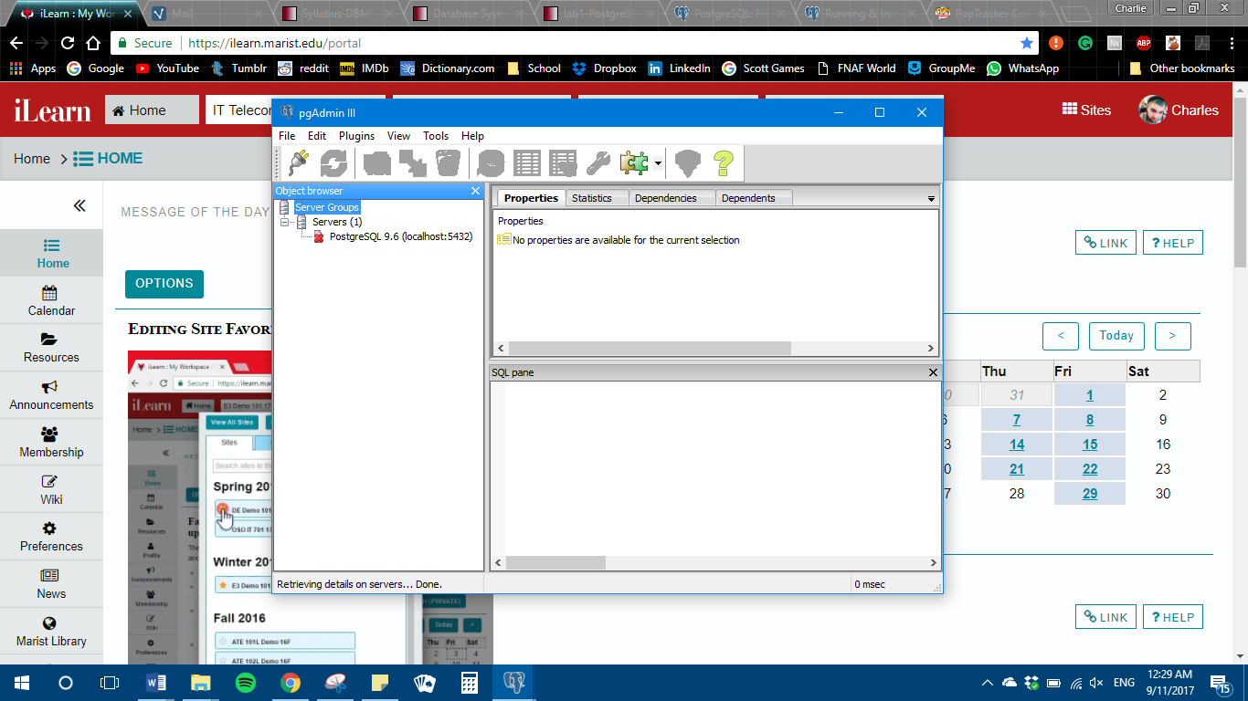

(Reminder: You also looked at my laptop and saw it up and running.)